SOFTWARE ENGINEERING
Assignment 01
Smart Stock Balancer
AI-Based Multi-Branch Inventory Redistribution System
Student Name | Khizra liaqat
Roll Number | 2025-APC-72
Course | Software Engineering
Submitted To | Sir Moaz
Program | Applied Computing

1. Project Overview and Problem Statement
Smart Stock Balancer is an AI-based inventory system for businesses that operate through multiple branches. It brings the stock data of all branches onto one centralized platform so that imbalances can be spotted and corrected quickly.
In many businesses, one branch holds far more stock than it needs while another runs short of the same item. The short branch then orders fresh stock from a supplier, even though the required quantity is already lying unused elsewhere. This causes unnecessary purchasing, higher costs, excess inventory at some branches and lost sales at others. Smart Stock Balancer uses AI demand forecasting to recommend an internal transfer instead, subject to a manager's approval.
Example: Wireless Mouse
Branch | Current Stock | AI Observation
Lahore | 100 | Enough for its own demand, with surplus left over
Islamabad | 5 | Predicted to need close to 40 units in the coming days
Faisalabad | 40 | Stock is balanced
Result: the system recommends transferring 30 to 35 units from Lahore to Islamabad, subject to manager approval, avoiding an unnecessary purchase.
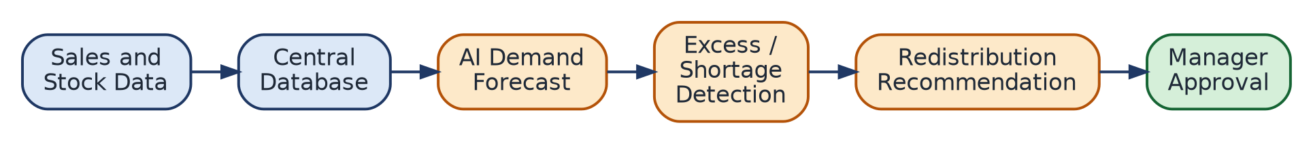
Overall System Flow

2. Purpose
To give multi-branch businesses one centralized platform where the inventory of every branch can be viewed together. It helps identify surplus and shortage quickly and uses AI recommendations to decide when an internal transfer is better than a new purchase order. The goal is to cut unnecessary spending, use existing stock better and reduce stockouts.

3. Users
Role | Main Responsibility
Admin | Manages branches, products, users and suppliers; monitors all inventory, transfers and reports.
Branch Manager | Handles one branch: records sales, checks low-stock items, creates or reviews transfer requests.
Inventory Manager | Works across all branches: compares stock, reviews AI recommendations, manages transfers, generates cross-branch reports.

4. Stakeholders
Stakeholder | Benefit
Business Owner | Reduced costs and improved profitability.
Suppliers | Affected because internal transfers reduce the number of fresh orders placed with them.
Customers | The product they want is available in-store because a timely transfer was made.

5. Functional Requirements
ID | Requirement
FR1 | The system shall let users log in and grant access based on their role (Admin, Branch Manager, Inventory Manager).
FR2 | The system shall record and update the current stock of every branch in real time.
FR3 | The system shall generate a low-stock alert when a product falls below its minimum stock level.
FR4 | The system shall use AI on historical sales data to predict future demand for each product at each branch.
FR5 | The system shall detect excess and shortage of the same product across branches and recommend a redistribution, which a manager must approve before any transfer.

6. Non-Functional Requirements
ID | Type | Requirement
NFR1 | Security | Users can access only the branch data and functions permitted by their role.
NFR2 | Performance | Stock updates and AI recommendations appear within a few seconds of a request.
NFR3 | Scalability | The system accommodates more branches, products and users without a noticeable slowdown.
NFR4 | Usability | The interface is simple enough for a non-technical Branch Manager to use comfortably.
NFR5 | Reliability | The system stays available so that sales and stock updates are never interrupted.

7. Risks
Risk | Impact | Mitigation
Incorrect AI Prediction | An unneeded transfer disturbs the stock balance of both branches. | Manager must approve every recommendation.
Data Synchronization Issues | Managers decide using outdated stock information. | Real-time stock updates from all branches (FR2).
Unauthorized Access | Fake transfer requests or altered stock data. | Role-based access control (FR1, NFR1) and audit trail.

8. Quality Attributes
- Accuracy: how closely AI predictions and recommendations match actual outcomes.
- Scalability: how well performance holds as branches, products and users grow.
- Security: how effectively data is protected and role-based access is enforced.

9. Where AI Is Used
- Demand Forecasting: predicts how much of a product each branch will need soon, from past sales.
- Excess and Shortage Detection: flags surplus and low-stock branches automatically.
- Smart Redistribution: suggests the best source, destination and quantity, including transport cost.
AI is a decision-support tool only. The manager always makes the final approve or reject decision.

10. What Could Go Wrong With AI
Problem | Safeguard
Wrong transfer decisions from poor or incomplete data | Use clean, complete sales data and check forecasts against actual sales.
Over-reliance on AI | Managers review each recommendation instead of approving blindly.
Automatic transfers without approval | No transfer is ever executed without manager approval.

11. Additional Enhancements
- Transfer cost display: shows estimated transport and handling cost against a new supplier order.
- Transfer status tracking: Pending, Approved, In Transit, Completed (Figure 2).
- Audit trail: records who requested and approved each transfer, and when.
- Notifications: alerts for new transfer requests and critical stock levels.
- Reports: sales, transfer history and excess/shortage summaries.
- Supplier management: Admin manages suppliers and places a purchase order when no suitable transfer exists.
- Maintainability (NFR): new branch types or product categories can be added without major rework.
- Transportation Delay (risk): delays in transit may leave the receiving branch temporarily out of stock.
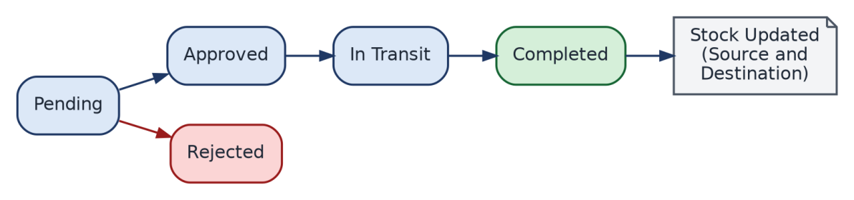
Transfer Status Flow

12. Cost-Aware Decision
The system does not recommend a transfer just because one branch has surplus. Moving stock has its own transport and handling cost, so it is compared with the cost of a new order. Rule: if Transfer Cost < Purchase Cost, recommend a transfer; otherwise, recommend a supplier order.
Option (30 units) | Cost | Result
Transfer from Lahore to Islamabad | Rs. 3,000 | Not recommended (higher cost)
New order from supplier (bulk discount) | Rs. 2,000 | Recommended (cheaper)
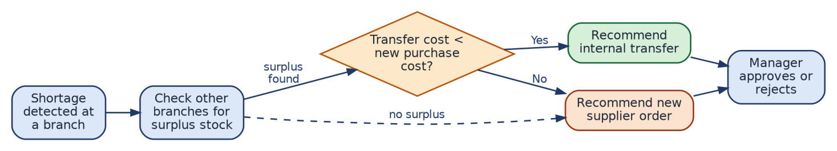
Figure 3: Transfer vs New Purchase Decision

13. Conclusion
Smart Stock Balancer helps multi-branch businesses use the stock they already own instead of buying more. AI forecasts demand and finds imbalances, while cost comparison makes sure a transfer is only suggested when it is financially sensible. Since every transfer needs manager approval, the system stays safe, reliable and easy to trust.

